The “Other” Mode on 2 Meters
Ed – KL7UW

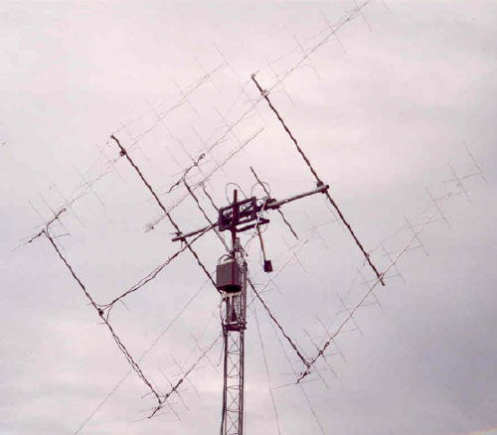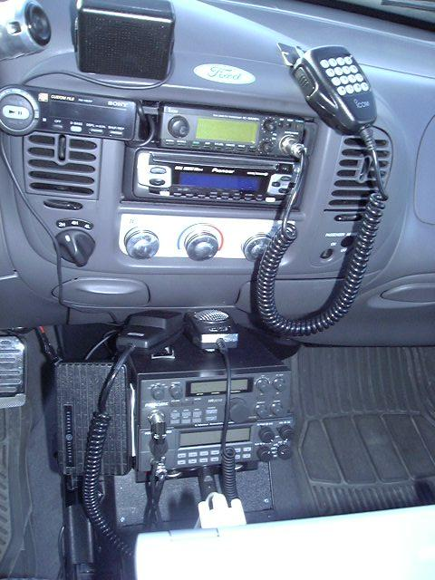
KL7UW KL7YK-mobile

Many hams are not aware of the use of SSB on the VHF bands or not sure how to start. I have included a good article written by Bob Witte, KØNR, about getting started with 2-meter SSB. Of course he gives information relevant to operation in Colorado so let me tell you what we are using here in South-central Alaska.

The Big City Simplex Net been active for many years on Tuesday nights at 2000 (8pm) on the frequency of 144.200 MHz USB. Current net control is KL7CY in Anchorage.

At the 2005 Anchorage Hamfest members of the new Alaska VHF-Up Group* met to discuss ways to encourage activity on the VHF and UHF bands, specifically using SSB for making long-range VHF contacts (this is so-called “weak-signal” operation). We decided to start a new Net featuring the VHF bands from 6m to 1296-MHz. The Net meets every Saturday at 0900 (9am).
See the Net schedule at http://www.qsl.net/ak-vhf/

It was decided that starting on 144.200 MHz would work best as more stations have multi-mode VHF radio equipment for 2-meters. KL7UW in Nikiski is net-control since he runs a large array of 2m yagi’s (photo above) and 90w.

The Alaska VHF Up Net was started with several stations checking in from the area (including three stations from the Kenai Peninsula and one from Glennallen). One night we even had KL7EDK from Fairbanks check in with about five stations working him via a bounce off Mt. McKinley!

Although the net starts on 144.200 we then progress to other bands: 50.125, 432.100, 222.100, and 1296.100 (all on USB). The net will occasionally hold an “FM net” to include stations that do not have VHF-SSB equipment.

There are a couple things we do different in Alaska than is described in the K0NR article. In Alaska we operate VHF SSB antennas in vertical polarity (the elements are aligned up and down) because so many stations migrate from FM activity. This permits any ham with a good 2-meter or 70-cm antenna to get on SSB with only the need for a multi-mode radio like the IC-706 (and others mentioned in the K0NR article). One exception is that most Alaskan 6-meter SSB stations are horizontally polarized.

On other thing that I would stress is to maximize the performance of a VHF-SSB station one should consider an antenna as high and in an unobstructed area as possible. Use of yagi antennas is desirable, and use of mast-mounted preamps makes possible hearing and working longer distances. Many stations also operate higher power using linear amplifiers (around 100 watts). But if all you have is a ten-watt 2-meter or 6-meter station and a whip why not try either VHF Net and join the fun! VHF is whole lot more than “repeaters”!

Now another way we are promoting VHF/UHF activity is by participation in the VHF Contests held several times a year. Ask about operating as a VHF rover from a mobile VHF station on SSB!

*For more information about VHF-SSB, the AK-VHF Net, VHF/UHF Contests, and the Alaska VHF-Up Group go to: http://www.qsl.net/ak-vhf/ read more from http://www.k0nr.com/rwitte/2Mssb.html

Or make a call on 147.27 MHz repeater and ask for information. Many of us hang out on the repeater, as well. Good VHF-DX and 73s - KL7UW

2015 Update:

A few things have changed since the publishing of this article in the AARC Newsletter.

The AK-VHF Net meets on 144.200 USB every Saturday starting at 9am except for the last weekend of the month when the net is conducted on 146.58 FM Simplex.

147.27 repeater was taken off the air so one should consider using 146.94 or 147.30 repeaters for looking for stations in the Anchorage-Valley area that also work VHF-plus SSB. Try 146.88 repeater in Kenai. Often one can bring up the 146.91 repeater in Homer.

If you have 222 FM equipment, try 223.50 Simplex as several monitor this frequency.

I now run 170w on 2m-SSB and 100w on FM with my four-yagi array. I have made contact with mobile and the occasional HT in Anchorage with this system. Even if you cannot copy me, there are stations in the Anchorage area that are willing to relay your check-in to the net.

AK VHF Up Group promotes activity in the ARRL VHF Contests held three times per year. The AK-VHF offers awards (see the website for more info)!

Weak-signal VHF-plus is not all Net or Contest activity. One can use the 50.125, 144.200, 223.50, or 446.00 calling frequencies to establish contacts. Folks need to add these frequencies in their scan list to monitor them.

There now are stations on all VHF/UHF bands from 6m to 1296-MHz in the South-Central Alaska Region (Kenai Peninsula to Talkeetna). Some of us have microwave gear and would love to show you how that is done.

Digital modes are becoming more popular for making long-distant VHF-plus contacts (e.g. WSPR and JT65). Modes such as meteor-scatter are making digital contacts over 1000-miles possible in the Northern Regions possible with a moderate-sized station. Check-in to the AK-VHF Net to find out more about all of these new developments and how to participate.

Ed – KL7UW
President – AK VHF Up Group
Net Contro: AK-VHF Net
50-MHz to 10-GHz

